April 26, 2024

The Honorable Chairman Cole
Chairman, House Committee on Appropriations
U.S. House of Representatives
Washington, DC 20515

The Honorable Ranking Member DeLauro
Ranking Member, House Committee on Appropriations
U.S. House of Representatives
Washington, DC 20515

Dear Chair Cole and Ranking Member DeLauro,
I am requesting funding for Ohio Jewish Communities on behalf of JewishColumbus in fiscal year 2025. The entity to receive funding for this project is JewishColumbus at 1175 College Avenue Columbus, Ohio 43209. The funding would be used to provide funding for police officers to deploy to at-risk Jewish institutions and COPS Technology & Equipment funding for advanced cameras and license plate reader technologies as well as communications, mapping, and geolocation tools in, at, or near at-risk Jewish institutions to deter and defend against terrorism.
The project is an appropriate use of taxpayer funds because additional officers will help protect at-risk communities in Ohio, and specifically, in my District. As well, the camera and license plate readers along with the communications, mapping, and geolocation tools will help leverage technology to 1) react more quickly, 2) provide transparency, and 3) allow for cross-jurisdictional cooperation in prevention, response, and investigation. The project has a Federal nexus because it is authorized under section 1701(b)(8) of the Omnibus Crime Control and Safe Streets Act of 1968 (34 U.S.C. § 10381(b)(8)). I certify that I have no financial interest in this project, and neither does anyone in my immediate family.

Sincerely,
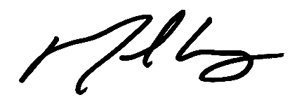
Mike Carey
Member of Congress

